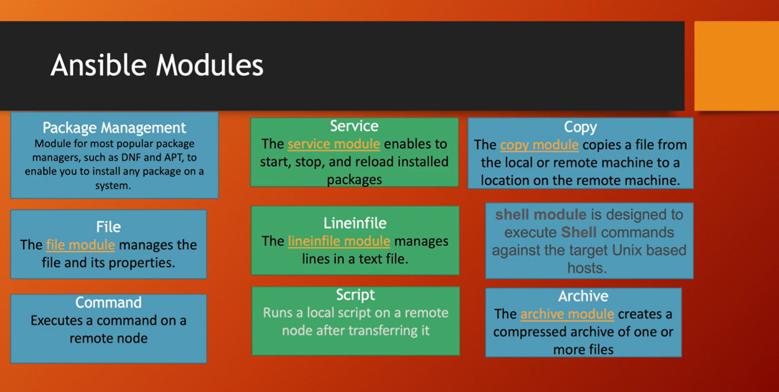

Runbook to install Git on node machine:
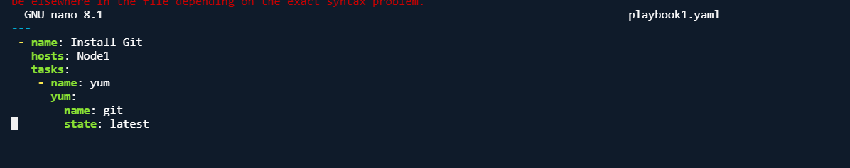
Inventory File:
Run Playbook:
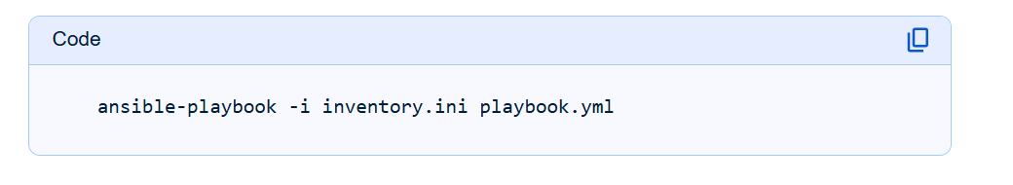

Service Module

